For the Beauty In Your Eyes

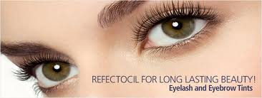

Eye Care
Eyelash Perming/Lifting 45
Eyelash Tinting 25

Eyelash Enhancements from 25
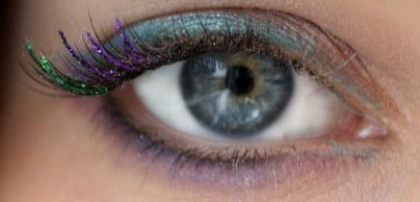
Eyebrow Tinting 25
Eyebrow Shaping 25

Beautifying Facial Eye Treatment

Reduces and prevents ageing, wrinkles, dryness lines,
dark circles and puffiness is diminished 49
Optimimum series of 4 169

Pure Kronoxyl-➈ Eye Contour Youth Integral Cure
A truly anti-ageing Home care cure created to correct and prevent the multiple and specific ageing signs of the eye contour area – wrinkles, dark circles and puffy eyelids.

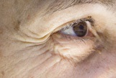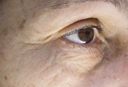
Before 0 Day After 30 Days
- helps correct the 3 types of wrinkles:
at the surface, from within and in depth through its “Botox®”-like effect on expression lines

- decreases the bluish aspect of dark circles

- reduces the look of puffiness

- improves the texture and glow

- helps prevent cutaneous ageing

